• Pacific Lamprey Conservation Initiative
Bonneville Power Administration Funding - FY23 Request for Proposals
• All fields marked with * are required and must be filled.
• • Project Name: *
Customization of a Novel Floating Elver Trap for Adult Pacific Lamprey Passage

• Total funding being requested from PLCI/BPA: *
Please indicate the total funding being requested from PLCI/BPA for this project.
$50,458

• Lead Project Applicant/Organization: *
Columbia River Inter-Tribal Fish Commission (CRITFC)
Yakama Nation Fisheries (YNF)

• Recipient of Funds (if different than Lead Project Applicant/Organization):
Funding will be administered through one contract to one organization. If subcontracts are necessary they will be administered by the project lead, and clearly reflected in the budget below.
Whooshh Innovations

• Full Name of Lead Point of Contact for Project: *
First Name Last Name
Laurie Porter / Ralph Lampman

• Email *
porl@critfc.org; lamr@yakamafish-nsn.gov

• Phone Number *
971-269-9412; 509-388-3871

• Project Type (choose all that apply): *
Passage Improvement

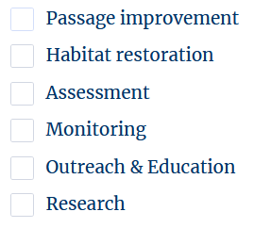
Identify the primary Lamprey Regional Management Unit (RMU) population addressed (on-the-ground work must occur in Columbia Basin RMUs indicated by*): *
Mainstem Columbia/Snake RMU
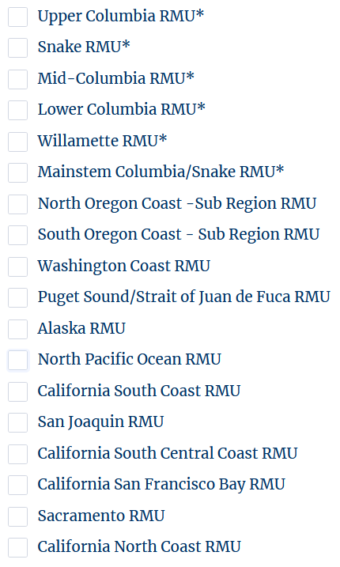
If the project will address additional RMUs beyond the one identified above, please identify any others that apply (please note: on-the-ground work must occur in Columbia Basin RMUs indicated by*): *

All!
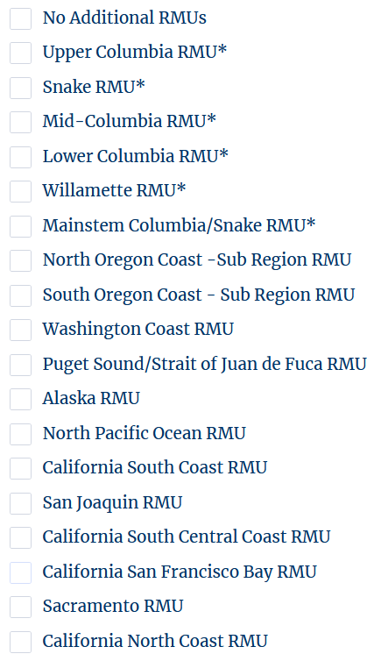
• 4th Hydrologic Unit Code (HUC) Field Name: *

Lower Columbia-Sandy
Middle Columbia-Hood

• Project Location *
(If multiple, please list each and describe. If unknown at this time, please indicate why.)
Bonneville Fish Hatchery, Bonneville Dam (Washington Shore Tailrace), The Dalles Dam (East Fish Ladder Tailrace).

• Project Coordinates (Latitude and longitude, decimal degrees, NAD 1983) *
If work is occurring at multiple sites a generalized location can be selected, however, please describe why/how it was chosen.

Bonneville Fish Hatchery = 45.633761, -121.956522
Bonneville Dam Site = 45.649725, -121.937560
The Dalles Dam Site = 45.619210, -121.120713

1. Project Description (20 points)

Short Project Summary (250 words or less):
- Provide a brief overview of your project including goals, objectives, and deliverables/outcomes and how the project will directly benefit lampreys and address needs nad threats identified in the Regional Implementation Plans (RIPs) of the RMUs where the project will occur and/or impact.
- This informaiton will be be used to describe your project in outreach materials and reports.
• Short project summary *
Despite extensive efforts and funding dedicated to improve passage at Lower Columbia River hydroelectric dams, adult Pacific Lamprey passage efficiency is still low (appr. 50-60% at Bonneville Dam). One of the key passage bottlenecks is at the fish ladder entrances, where weaker swimming adults struggle to enter the existing fish ladders. We plan to develop, customize and test a novel mobile floating trap for passing adult Pacific Lamprey. The proposed design is based on an existing commercially available floating pontoon trap for Atlantic juvenile eels (elvers migrating upstream). The existing elver trap uses a small pump for attraction flow, has two sloped climbing ramps, and is wetted by the pumped river water leading to gravity trapping chambers that run parallel and adjacent to the pontoons. This project would involve design modifications for the trap, including redesign of the trapping chambers to accommodate the larger lamprey body sizes and also lining of the chambers with non-attachable surfaces to prevent escapement and any extensive holding. After fabrication and laboratory testing, we will deploy the unit at test sites on the Lower Columbia River and monitor its effectiveness. These traps could potentially be set up not only at mainstem dams, but also tributary dams for collection, translocation and volitional passage. If the testing proves successful, this trap can be easily combined with 4-inch flexible tubing to create a complete volitional passage solution that is relatively portable, comparatively inexpensive and easy to deploy in locations where lamprey have difficulty using traditional fish passage structures.
0/250
• Detailed Project Description (500 words or less):
- Describe how the proposed work will directly benefit and/or is focused on lampreys.
- Describe specific overarching goals, measureable objectives, major milestones, and deliverables.
- Clearly state how findings and deliverables from the project will be desseminated, including any outreach to public, practicioners, and/or partners.
- Identify and describe any partners (tribal, federal, state, local, watershed associations, etc.) supporting and implementing the project, including what role they have in the project (supplemental funding, subcontractors, implementation, technical assistance, etc.)
• Detailed Project Description *
The project is based on an existing, tested design for another upstream migrating species - European eel (Anguilla anguilla) elvers (juveniles). The mobile, floatable trap can be deployed virtually any water body and has been used in key strategic locations to help pass juvenile eels at man-made structures. The mobile trap consists of two ramps of 0.5 m length and 2.4 m width, with the entrances positioned away from each other perpendicularly to the stream flow. The ramps are fastened to floating devices and held together by an aluminum frame (see illustrations below). Pumped water (~5 L/s) is released along the entire width of the entrances on both sides. Eels that climb the ramps fall into a channel and were guided into a livewell located underneath the trap. From these chambers the elvers are literally pumped to shore based, or submerged, collection vessels awaiting transport. Design changes were proposed by lamprey experts (Columbia Inter-Tribal Fish Commission member tribes staff ) to exploit the behavior of migrating lamprey when they encounter a flow or structural barrier. Four key design changes included: 1) remove the climbing substratum on the ramp to create a smooth climbing surface, 2) use a 4-inch tube for routing the adults rather than a livewell underneath the trap, 3) increase the size of the trapping chamber to accommodate adult lamprey, and 4) incorporate material changes to prevent lamprey to hold extensively or alternatively escape the structure (other than through the guided chamber route). The illustrations below help describe some of these redesign details.

If we can place this passage structure in known bottlenecks for lamprey passage (where we know lamprey congregate due to passage difficulty), it has the potential to provide an alternative passage route for many thousands (and potentially tens of thousands) of lamprey. Prior to deployment we plan to test the trap in a lab environment first to ensure the design is as effective and efficient as possible and identify any other changes or finetuning that may be needed to be most successful. We plan to use one of the 20-ft diameter large circular tanks at Bonneville Fish Hatchery to test the trap with fresh migrant adults collected from Bonneville Dam. The Columbia River Inter-Tribal Fish Commission currently has access to this facility for temporarily holding collected adults for translocation purposes. For this project, we selected two key sites for passage improvement: 1) Tailrace of the Washington Shore Fish Ladder Entrance at Bonneville Dam and 2) Tailrace of the East Fish Ladder Entrance at The Dalles Dam. The two locations are passage portals for the largest number of upstream migration adult Pacific Lamprey in the world and our team thought they would be the best location to test the effectiveness of this alternative passage design.

0/500
• Upload photos/illustrations, and maps to provide further understanding of the project. *
Browse Files
Drag and drop files here
Limit to three total

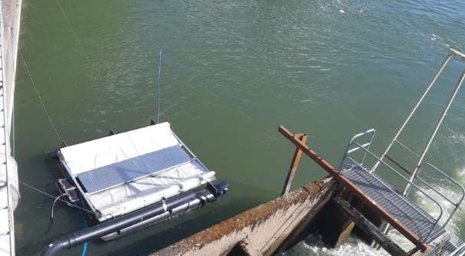
Figure 1. Existing mobile floating trap used for elver eels.

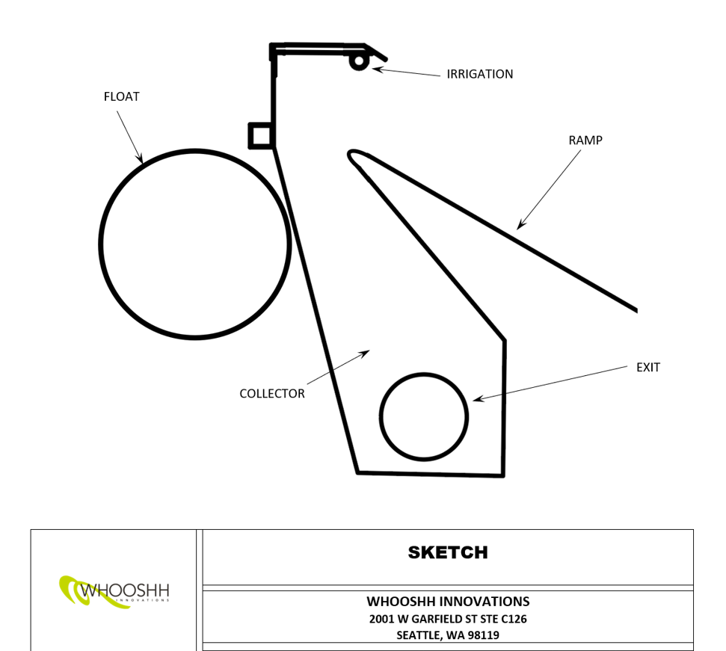
Figure 2. Proposed capture chamber modifications. Irrigation sprays water to both the ramp as well as the collector chamber. The inside of the collector chamber will be perforated (or covered with other types of surfaces that will prevent suction mouth attachment). The collector chamber will be wider at the bottom to allow them to turn around to face the incoming flow direction.

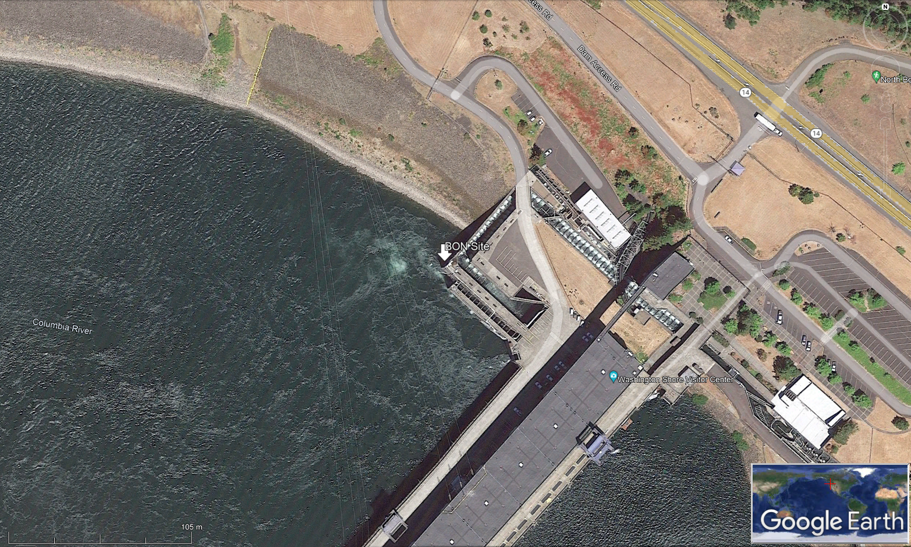
Figure 3. Proposed location of deployment at Bonneville Dam facility (near the Washington Shore Fish Ladder entrance in a hydrologically well protected area).

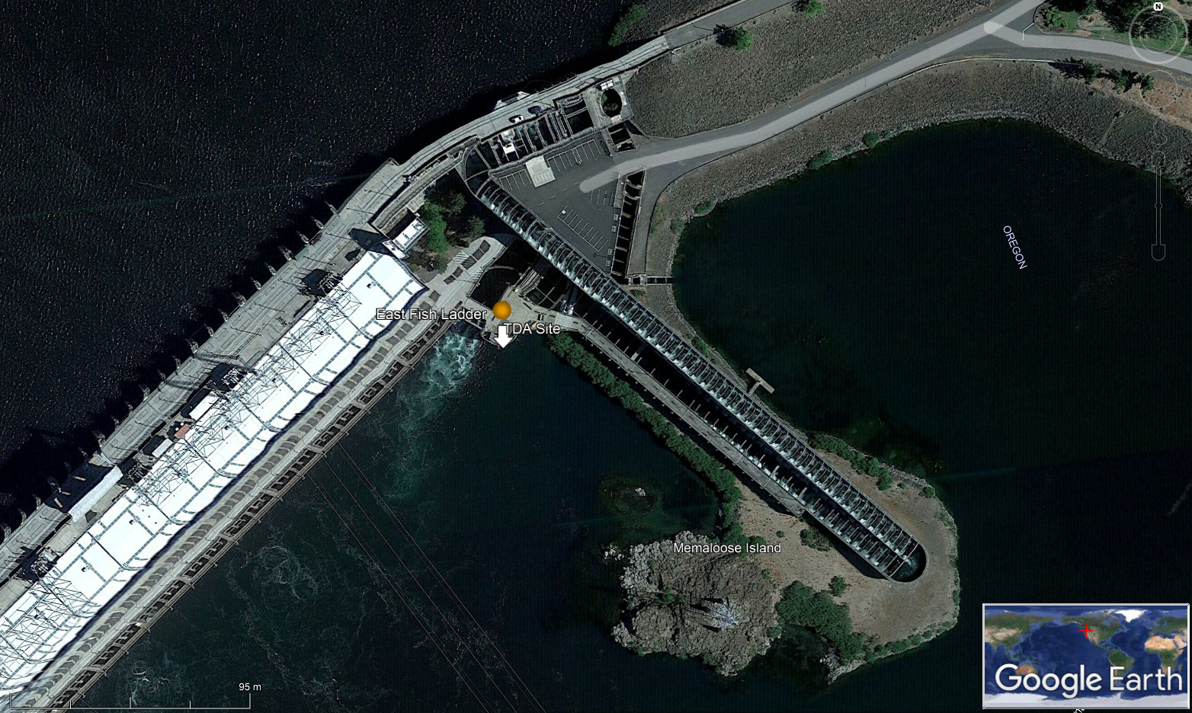
Figure 4. Proposed location of deployment at The Dalles Dam facility (near the East Fish Ladder entrance in a hydrologically well protected area).
• 2. Project Feasibility (20 points)
- If applicable, have the designs for the project been completed or will they be completed before planned project implementation? Please describe current status of designs (e.g., 30, 60, 90%), if designs have been reviewed, and be prepared to provide any technical designs or documents for further review upon requestion.
- What permits are in place already and/or will be before planned project implementation? (e.g., ESA consultation, Scienctific Collection, fish health/transport, etc.). Be prepared to provide documentation upon request. In addition depending on funding stream added environmental compliance coordination and work may be necessary.
- Is the implementation of this project contingent on any other needed materials, projects, or funding.
• Please describe based on the relevant elements above and any others you feel demonstrate the feasibility of this project. *

- The floating elver trap is already commercially available and has been deployed at several locations worldwide. Results have been consistently better than traditional passage mechanisms for elver (juvenile eels).
- The proposed lamprey modifications needed for the trap have been already discussed and designed and shared by tribal lamprey experts in consultation with the manufacturer.
- All scientific collection permits will be attained by CRITFC member tribes (e.g., Yakama Nation Fisheries) working in close communication with the U.S. Army of Corps Engineers (ACOE). Installation will be in 2024, so there is sufficient time available to work out any type of new permits that may be needed in association with this new type of a floatable trap. Conversations to date with the ACOE indicate that installation of these traps can be accommodated as long as they are deployed in safe locations with the right resources and access permits.

• Timeline of major tasks and milestones. Customize the table below as needed, and include the desired contract start and end dates as your first and last tasks respectively. *
See below

 | Workflow (Describe the Task) | Start Date (Month/Year) | End Date (Month/Year) | Responsible Party(s)
Task 1
Task 2
Task 3
Task 4
Task 5
Task 6
Task 7
Task 8
Task 9
Task 10
Task 1: Design modifications for adult Pacific Lamprey
Start Date: April 2023
End Date: May 2023
Responsible Party(s): Whooshh Innovations
Task 2: Fabrication of the mobile floating trap for Pacific Lamprey
Start Date: May 2023
End Date: July 2023
Responsible Party(s): Whooshh Innovations
Task 3: Testing, improvement, and fine-tuning of effectiveness at Bonneville Hatchery (with a 20-ft large circular tank using adults collected from Bonneville Dam)
Start Date: July 2023
End Date: September 2023
Responsible Party(s): CRITFC and member tribes
Task 4: Modification of the structure based on test trials
Start Date: September 2023
End Date: May 2024
Responsible Party(s): CRITFC and member tribes
Task 5: Installation and testing of effectiveness at Bonneville Dam and/or The Dalles Dam
Start Date: May 2024
End Date: September 2024
Responsible Party(s): CRITFC and member tribes
Task 56: Final Report
Start Date September 2024:
End Date: December 2024
Responsible Party(s): CRITFC and member tribes, Whooshh Innovations

3. Linkage of Actions to Identified Threats to Lampreys (15 points)
For the next two questions, please reference the Regional Implementation Plans (RIPs) for each Regional Management Unit(s) (RMUs) where this project will occur. RIPs can be found on PLCI's website here: www.pacificlamprey.org/rmu/
• What threat(s) to lampreys does this project address? (Refer to the RIPs for the RMUs where the project occurs for key threats.) *

Passage, Predation, Disease, Climate Change

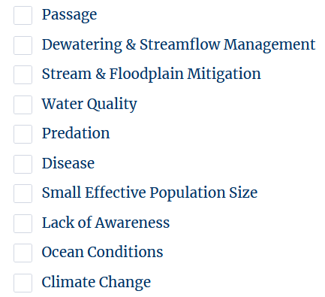
• Referencing the relevant RIPs, describe how this project addresses each of the key threat(s) to lampreys within the HUC(s) and RMU(s) where this project is proposed. If the project occurs in more than one RMU, please indicate which threats addressed apply to which RMU. *
Currently there is no RIP for the Mainstem Columbia/Snake RMU. However, it is abundantly clear that all of these threats in the list are critical in this RMU, especially “Passage.” This project focuses primarily on improving the adult passage threat (at two of the most important passage barriers not only within the RMU but in the “world”) and will simultaneously provide net positive impacts in relation to threats associated with water quality, predation, disease, and climate change by mitigating the impacts of these threats experienced by adult lamprey. See below for a more detailed explanation.

0/300
• 4. Species/Habitat Benefits (15 points)
- Provide citation of literature, distribution maps, and/or surveys demonstrating lampreys are currently and/or were historically present in the project area.
- How will the project provide meaningful measureable results to improve lamprey populations and/or their habitat conditions?
- What life stage or stages of lampreys will benefit from action? How?
- Demonstrate that the proposal provides meaningful measureable results to improve lamprey populations and/or their habitat conditions, and work proposed will benefit lamprey directly, and/or inform/guide future projects that will benefit lamprey (e.g. assessments).
- What other species may benefit from this project?
• Description of Species/Habitat Benefits *

For this project, we selected two key sites for passage improvement. Bonneville Dam is the single most important passage portal for the largest number of upstream migrating adult Pacific Lamprey in the entire world. Among all the fish ladders at Bonneville Dam, Washington Shore Fish Ladder in particular provides access to the largest number of Pacific Lamprey consistently annually (a large portion of the adults are migrating on this side). Given the importance of this facility as well as this particular fish ladder location, if we can provide an effective alternative passage route for all of the adults that swim up to this site, there is a high potential to improve passage for the largest number of Pacific Lamprey. Unfortunately, 40-50% of the adult Pacific Lamprey that reach Bonneville Dam are still not successful in passing the dam. A passage structure downstream and outside of the fish ladder facility has the potential to provide passage to a very large number of adults that actually never make it inside the fish ladder. In addition, a considerable number of adults are also disappearing somewhere between Bonneville Dam reservoir and The Dalles Dam. The two fish ladder entrances at The Dalles Dam are known to be difficult and challenging for adult lamprey to enter due to a combination of the high velocity environment and the abundance of interrupted non-smooth surfaces created by their weir gate slots. Provision of an alternative passage structure just downstream and outsite the entrance to the East Fish Ladder of The Dalles Dam will also create a critical passage portal to those adults that may be struggling to enter the dam.

Considerable predation activities also occur at Bonneville and The Dalles dams. Seals, sealions, and river otters are examples of mammals that prey on migrating adult Pacific Lamprey as they migrate near these hydroelectric dams. In addition, large-sized bird and fish species can also feed on adult Pacific Lamprey, including ospreys, bald eagles, great blue herons, and sturgeons. Providing an alternative passage route downstream of the fish ladder entrance that allows lamprey to circumvent and bypass the entire dam can help minimize predation that naturally occurs at these dam facilities as lamprey struggle to pass certain passage bottlenecks. In addition, during the warmer summer months at Bonneville Dam, many of the adult lamprey can succumb to a combination of the high water temperature and potential heat-induced pathogens (e.g., Aeromonas salmonicida, the pathogen for furunculosis). Due to the extended time that many of the adult lamprey spend in the concrete fish ladders (which lack natural cold-water refuges), they can eventually succumb to the elevated stress and diseases. Finally, this trend of ever-increasing summer water temperatures is only expected to worsen in the future. Due to climate change, more lamprey are likely to experience water that hovers near their upper tolerance for temperature while navigating and swimming through these Lower Columbia River hydrodam facilities. The impacts from contaminants also tend to worsen in warmer water environments. Contaminants are abundant and pervasive in the mainstem Lower Columbia River environment; for example, Bradford Island was just recently listed and designated as a new Superfund site on the National Priorities List. The combination of high temperatures, contaminants, predation, and diseases will likely synergistically elevate the negative impacts that adult lamprey face as they migrate through the Lower Columbia River hydrodam fish ladders, contributing cumulatively to their passage success. Providing alternate passage routes that circumvent their passage duration will greatly help their chances of survival.

• 5. Relevance to Regional/National Plans and Strategies (10 points)
The following strategies, restoration and/or management plans are referenced in the questions below. Each is linked here for reference:
- Pacific Lamprey Conservation Agreement
- Bonneville Power Administration (BPA)/Northwest Power and Conservation Council (NPCC) Columbia River Basin Fish and Wildlife Program
- Columbia River Inter-Tribal Fish Commission (CRITFC) Tribal Pacific Lamprey Restoration Plan for the Columbia River Basin
• Indicate the objectives in the Pacific Lamprey Conservation Agreement (see pages 5-6 in the 2012 Agreement) that are addressed by this project. *

7

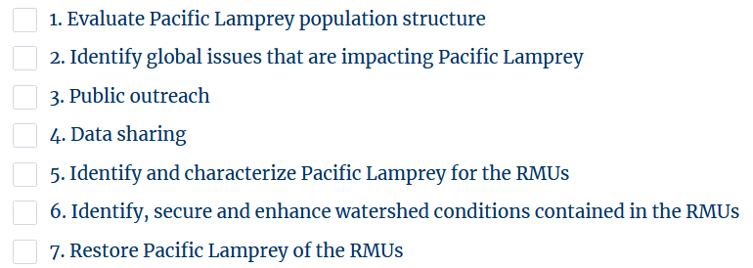
• Clearly describe how the project would address the specific objectives listed in the Pacific Lamprey Conservation Agreement indicated above. *

As described above, we selected two key sites for passage improvement. Bonneville Dam is the single most important passage portal for the largest number of upstream migrating adult Pacific Lamprey in the entire world. A passage structure downstream and outside of the fish ladder facility has the potential to provide passage to a very large number of adults that actually never make it inside the fish ladder. In addition, a considerable number of adults are also disappearing somewhere between Bonneville Dam reservoir and The Dalles Dam. Provision of an alternative passage structure just downstream and outside the entrance to the East Fish Ladder of The Dalles Dam will also create a critical passage portal to those adults that may be struggling to enter the dam. By focusing on improving passage at these two key sites, we will have a positive impact on not only the Mainstem Columbia/Snake RMU, but all the other RMUs within the Columbia River Basin (as well as all other RMUs in the long-run as a result of the panmictic nature of their ocean and river migration and distribution).

• Indicate the adult abundance and other populations targets for Pacific Lamprey identified in the BPA/NPCC Columbia River Basin Fish & Wildlife Program (page 19 of the 2020 Addendum) that are addressed by this project. *
L1, L2, L3
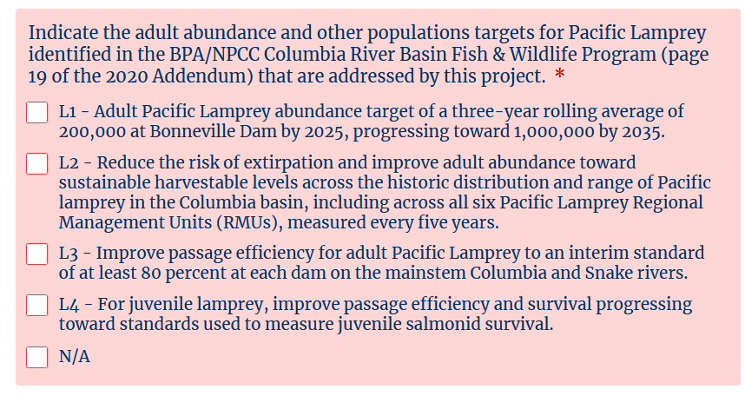
• CClearly describe how the project would address the specific goals and targets listed in the BPA/NPCC Columbia River Basin Fish & Wildlife Program indicated above. *

As described above, we selected two key sites for passage improvement. Bonneville Dam is the single most important passage portal for the largest number of upstream migrating adult Pacific Lamprey in the entire world. A passage structure downstream and outside of the fish ladder facility has the potential to provide passage to a very large number of adults that actually never make it inside the fish ladder. In addition, a considerable number of adults are also disappearing somewhere between Bonneville Dam reservoir and The Dalles Dam. Provision of an alternative passage structure just downstream and outside the entrance to the East Fish Ladder of The Dalles Dam will also create a critical passage portal to those adults that may be struggling to enter the dam. By focusing on improving passage at these two key sites, we will have a positive impact on not only the Mainstem Columbia/Snake RMU, but all the other RMUs within the Columbia River Basin (as well as all other RMUs in the long-run as a result of the panmictic nature of their ocean and river migration and distribution).

This pilot project will investigate the true potential of providing alternative passage to the large number of adult lamprey (30-50%) that never passes these hydroelectric dams. If successful, it has the potential to become a permanent structure for passage at these dams, which will be managed and operated by the U.S. Army of Corps Engineers. If our goal is to improve passage to at least 80% levels (from 50-60% levels currently detected at Bonneville Dam), it is essential and crucial that we focus on these areas of the dam; otherwise, this goal will remain a far-fetched unrealistic goal. By achieving this goal, we will open up the door to increase abundance to 200,000 (by 2025) and eventually 1,000,000 (by 2050).

• Indicate the objectives and actions in the CRTIFC Tribal Pacific Lamprey Restoration Plan for the Columbia River Basin (see pages 23-98) that are addressed by this project. *

1, 2, 3, 4

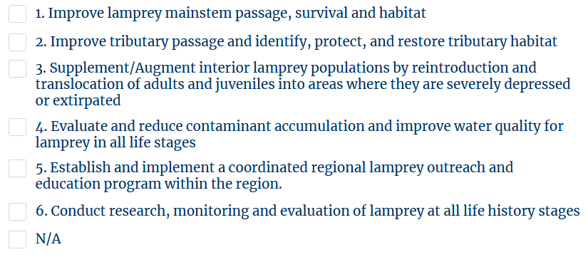
• Clearly describe how the project would address the specific objectives and actions listed in the CRTIFC Tribal Pacific Lamprey Restoration Plan for the Columbia River Basin indicated above. *

This project addresses 1, 2, 3, and 4.
As described above, we selected two key sites for passage improvement. Bonneville Dam is the single most important passage portal for the largest number of upstream migrating adult Pacific Lamprey in the entire world. A passage structure downstream and outside of the fish ladder facility has the potential to provide passage to a very large number of adults that actually never make it inside the fish ladder. In addition, a considerable number of adults are also disappearing somewhere between Bonneville Dam reservoir and The Dalles Dam. Provision of an alternative passage structure just downstream and outside the entrance to the East Fish Ladder of The Dalles Dam will also create a critical passage portal to those adults that may be struggling to enter the dam. By focusing on improving passage at these two key sites, we will have a positive impact on not only the Mainstem Columbia/Snake RMU, but all the other RMUs within the Columbia River Basin (as well as all other RMUs in the long-run as a result of the panmictic nature of their ocean and river migration and distribution).

This pilot project will investigate the true potential of providing alternative passage to the large number of adult lamprey (30-50%) that never passes these hydroelectric dams. If successful, it has the potential to become a permanent structure for passage at these dams, which will be managed and operated by the U.S. Army of Corps Engineers. If our goal is to improve passage to at least 80% levels (from 50-60% levels currently detected at Bonneville Dam), it is essential and crucial that we focus on these areas of the dam; otherwise, this goal will remain a far-fetched unrealistic goal. By achieving this goal, we will open up the door to increase abundance to 200,000 (by 2025) and eventually 1,000,000 (by 2050).

Successfully achieving this mainstem passage objective will lead to increased passage in tributaries as well due to the Lower Columbia River being a life line for all the tributaries within the system. It will also provide a unique means for CRITFC member tribes to collect adult lamprey for translocation, increasing the number of adults that we can bypass the dam and provide access to more productive upstream habitat. By bypassing the entire dam and fish ladder, these adult lamprey will no longer have to endure the low water quality (high temperature and contaminants) environment for extended periods and can provide an effective mitigation (while we wait for these conditions to hopefully improve in the long-term).

• 6. Evaluation and/or Monitoring (10 points)
Describe how the project's successful completion will benefit lampreys and will be evaluated and/or monitored over time and provide clear metrics on these benefits. Examples include, but are not limited to:
- Habitat restoration and passage projects should include post-project monitoring.
- Reserach, evaluation, assessment and outreach projects hsould include how the resulting information will benefit lamprey conservation.
• Description of monitoring and evaluation. *

Following the redesign additional stages would include fabrication, laboratory testing, and then deployment and monitoring at test sites on the Lower Columbia River. We will monitor the effectiveness in the lab environment first (with a known number of adults in the tank). During the field testing, we will count every single adult lamprey that uses and or attempts to use the trap and will provide a safe environment for their continued passage and survival (to be translocated upstream of the dam). Once the pilot project is tested and proven to be effective during this project duration, the CRITFC member tribes will work closely with the U.S. Army of Corps Engineers to convert the structure to a more permanent structure (which may still be floatable and somewhat mobile) that will be deployed and operated annual at key dam facility locations to help ensure as many of the weak swimmer adults have an opportunity to pass these large hydroelectric dams on the mainstem Columbia and Snake rivers.

• If you have a monitoring plan or other document you'd like to upload please do so here.
Browse Files
Drag and drop files here

Attach the Watz et al. 2017 paper and supplemental information and my short report.
• 7. Project Budget (10 points)
Using BPA's Line Item Budget Template and a short budget narrative, please provide a project budget that includes all aspects (tasks, deliverables, etc.) of the project.
Also clearly describe and include all matching funds and/or in-kind services that directly contribute to the project and indentify in the budget which project partners are providing this support, to what aspect of the project, and whether or not hte support is secured.
• Budget Narrative *
This project will require personnel time for the designing and fabrication of the adult passage structure (including post lab testing modifications), travel and mileage costs to visit the field work locations (Bonneville Fish Hatchery, Bonneville Dam, and The Dalles Dam), the cost for the custom modified floating trap for field testing, and indirect rates by Whooshh Innovations. See the budget spreadsheet for more details. Staff from CRITFC and member tribes will provide in-kind cost share to help manage and administer the project, working with key partners on the ground. Combined estimated in-kind contribution is $50,000 for the project duration.

0/200
• Upload the budget for your project using BPA's Line Item Budget Template *
Browse Files
Drag and drop files here

